**2. ReactJS-HOL-student-app**

**//About.js**

import React, { Component } from "react";

export class About extends Component{

render(){

return(

<div>

<h3>Welcome to the About page of the Student Management Portal</h3>

</div>)

}

}

**//contact.js**

import React, { Component } from "react";

export class Contact extends Component{

render(){

return(

<div>

<h3>Welcome to the Contact page of the Student Management Portal</h3>

</div>)

}

}

**//Home.js**

import React, { Component } from "react";

export class Home extends Component{

render(){

return(

<div>

<h3>Welcome to the Home page of the Student Management Portal</h3>

</div>)

}

}

**//App.css**

.container {

padding: 20px;

max-width: 1200px;

margin: auto;

display: flex;

flex-direction: column;

align-items: center;

justify-content: center;

gap: 20px;

}

body {

font-family: Arial, sans-serif;

font-style: italic;

margin: 0;

}

**//App.js**

import './App.css';

import {Home} from './components/Home';

import {About} from './components/About';

import {Contact} from './components/Contact';

function App() {

return (

<div className="container">

<Home/>

<About/>

<Contact/>

</div>

);

}

export default App;

**//index.js**

import React from 'react';

import ReactDOM from 'react-dom/client';

import App from './App';

import reportWebVitals from './reportWebVitals';

const root = ReactDOM.createRoot(document.getElementById('root'));

root.render(

<React.StrictMode>

<App />

</React.StrictMode>

);

// If you want to start measuring performance in your app, pass a function

// to log results (for example: reportWebVitals(console.log))

// or send to an analytics endpoint. Learn more: https://bit.ly/CRA-vitals

reportWebVitals();

**//reportWebVitals.js**

const reportWebVitals = onPerfEntry => {

if (onPerfEntry && onPerfEntry instanceof Function) {

import('web-vitals').then(({ getCLS, getFID, getFCP, getLCP, getTTFB }) => {

getCLS(onPerfEntry);

getFID(onPerfEntry);

getFCP(onPerfEntry);

getLCP(onPerfEntry);

getTTFB(onPerfEntry);

});

}

};

export default reportWebVitals;

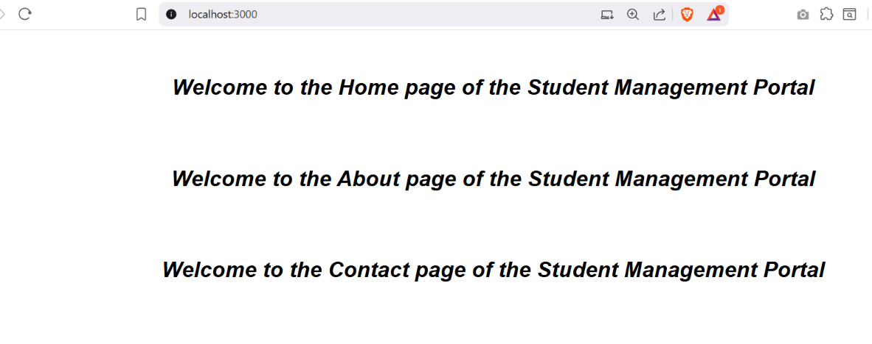**OUTPUT:**